JAVA EXCEPTIONS
Exceptions: Abnormal Condition that occurs during execution of a program that disrupts the normal flow that caused by the application itself.
Exception Handling: Technique of handling unexpected failures that could occur in a program so that the program does not terminate and normal execution flow is maintained
If the exceptions are not handled properly the application will be terminated abruptly.
Try block: The code is monitored for exception or the place where exception can be thrown.
Catch block: It catches the exceptions occurred in try block.
Finally Block: Always executed when or whether exception is occurred or not. Used for closure details.
System.exit(0): Finally won’t be executed
Error: Abnormal error that Caused by the running environment or platform and in the scope that cannot be recovered.
StackoverflowError: Occurs when stack value overflows.
Exception in thread main:
OutOfMemoryError: JVM runs out of heap memory.
Fix: java MyProgram -Xms1024m -Xmx1024m -XX:PermSize=64M -XX:MaxPermSize=256m
NoSuchMethodError: When method is not present (If we remove static keyword from method)
UnsupportedClassVersion Error: Occurs when the Java class is compiled from one JDK version and we run the class in another JDK version.
NoClassDefFoundError: This occurs if a ClassLoader is unable to find that class in the class path at the time of loading it.
Try, catch, finally conditions:
- No statements should be present in between try and catch.
- Before Java8 we need try block to be followed by catch or finally and not allowed to use only try block.
- Statement present after the line throwed exception in try won’t be executed
- try-with-resources
Unreachable catch block / hierarchy of catch: Sub class should come first and superclass later.
Multiple/Union Catch Blocks: We can use multiple catch blocks for different exception-handling logic for different types of exceptions occurring in code.
Java7 introduced the feature to union the catch blocks - handle multiple exceptions in the same catch block.
Exception Propagation: Process where the compiler makes sure that exception is handled. If not the exception goes down the call stack and reach the main method and terminates.
Printstacktrace: Printstacktrace prints the detailed information about the exception occurred.
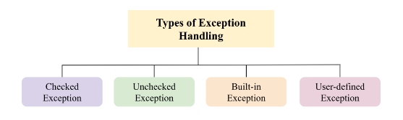
Checked Exception: Occur during the compilation. Here, the compiler checks whether the exception is handled and throws an error accordingly.
Unchecked Exceptions: Occur during program execution. These are not detectable during the compilation process.
Super class of all the exceptions:
Throwable class is the super class of all the classes.
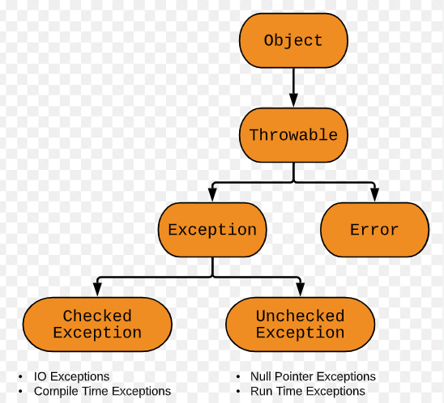
Methods in Throwable class:
- getMessage(): returns the message string about the exception.
Syntax: public String getMessage()
- getCause(): returns the cause of the exception. It will return null is cause is unknown or non-existent.
Syntax: public Throwable getCause()
- toString(): returns a short description of the exception.
Description of the exception = class name + “: “+ message.
Syntax: public String toString()
- printStackTrace(): prints the short description of the exception(using toString()) + a stack trace for this exception on the error output stream(System.err).
Syntax: public void printStackTrace(PrintStream s)
Runtime Exceptions: Occurs at the runtime of the program execution and not known to the compiler.
All subclasses of the java.lang.RunTimeException class and java.lang.Error class belongs to runtime exceptions. They are called Unchecked exceptions.
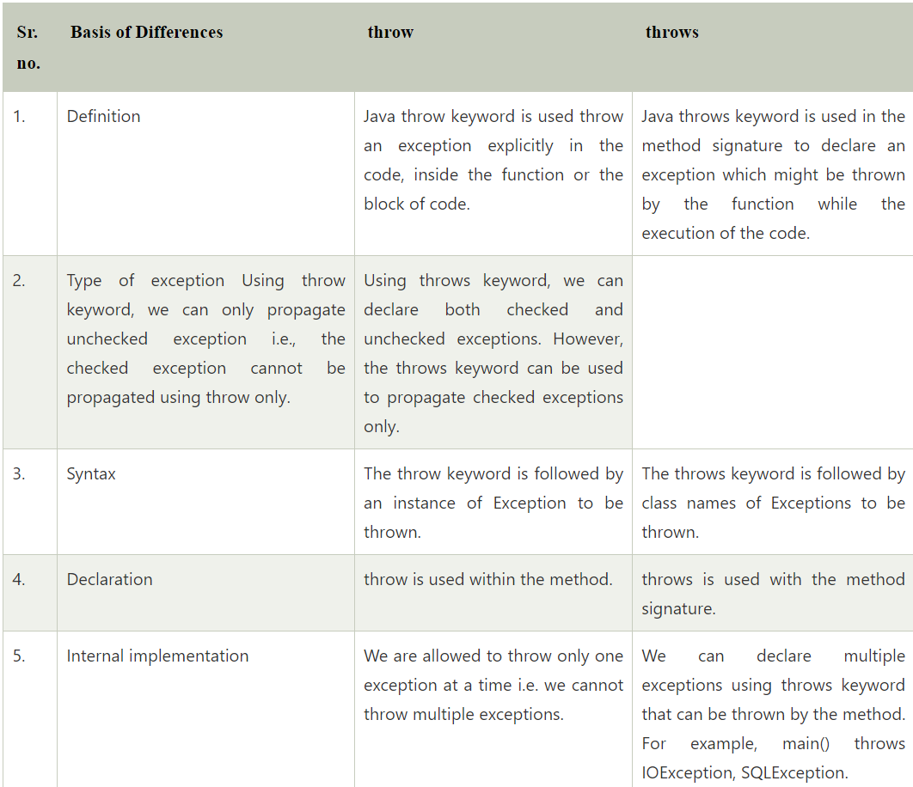
Throw keyword Restrictions: You cannot use throw keyword with a static block, and more over a static block is invoked at compile time (at the time of class loading) no method invokes it.
Rethrow: When the try block throws the exception and the catch block is unable to handle the exception, we need to rethrow the same exception again using the throw keword.
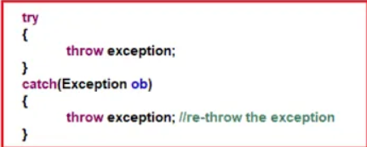
Stack Trace: Stack Trace has the information of name of the class and methods from the start of the program where the exception is occurred. It s used to debug the issue.
Exception Chaining: One exception causes/associates another exception then it causes/associates another and goes on.
Final, Finally and Finalize:
Final keyword:
- class -> cannot be inherited
- method -> cannot be overridden
- variable -> cannot be modified
Finally: Code block always executed when or whether exception is occurred or not. Used for closure details.
Finalize: Method runs before the garbage collector runs to clear the memory.
Exception Hierarchy:
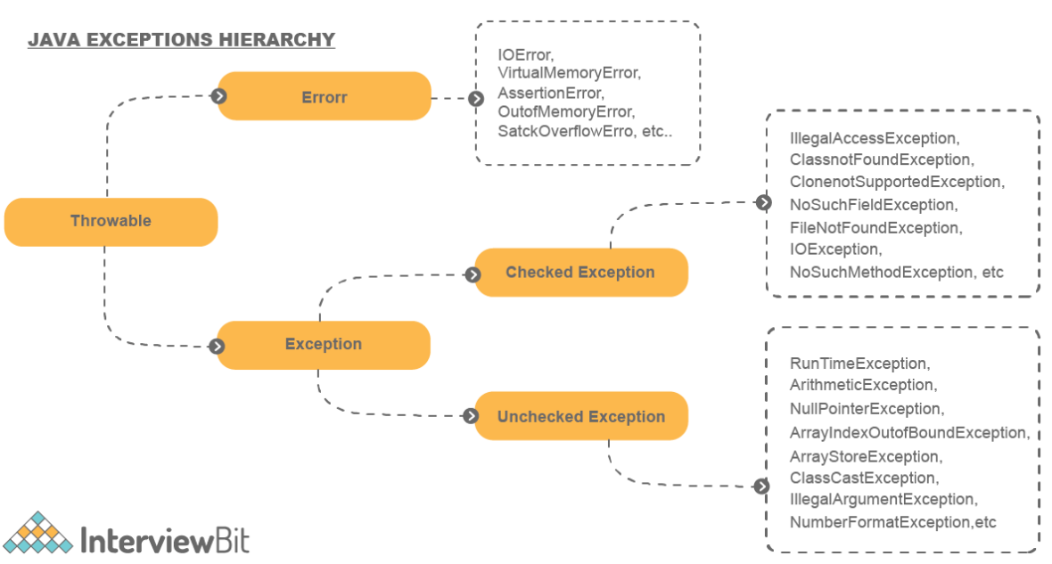
If exception thrown by main method and not handled properly the Java Runtime will terminate the program and the exception message is printed in the console by print stack method.
Custom Exception: When we don’t have the exception that is not represented by any of the existing Exception types, we can create a customized exception.
Custom Exception Creation:
- Extend Exception for checked exceptions, which must be handled or declared in the method signature.
- Extend Runtime Exception for unchecked exceptions, which do not require explicit handling or declaration.
- Add Constructor in custom exception class and pass the message to superclass using super () and use throw keyword.
Rules we should follow when overriding a method throwing an Exception:
- If the parent class method is not throwing any exceptions, then the overridden child class method should not throw checked exceptions. But it can throw an unchecked exception.
- If the parent class method is throwing one or more checked exceptions, then the overridden method in the child class can throw any unchecked exceptions or any exceptions that are the same as checked exceptions of the parent method or the subclasses of those checked exceptions.
- If the parent class method has a throws clause having unchecked exceptions, then the overriding child method can throw any number of unchecked exceptions even if they are not related to each other.
Checked Exceptions:
Checked exceptions do not occur at compile-time. All exceptions always occur at runtime only but some exceptions are detected at compile-time and some other at runtime.
Ex: FileNotFoundException detect the path may not throw exception in compile time but throw runtime exception if the file is not present in runtime.
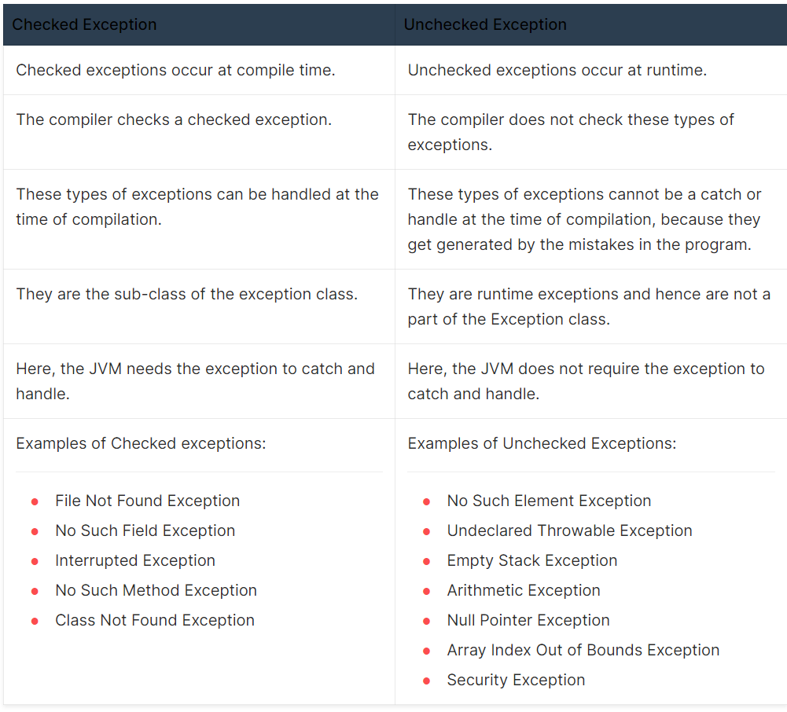
Try with resources: Avoid resource leakage and automatically closes the resources [From Java 8]. Pass object reference (or) create object in try block (or) declare reference in the declare statement.
Try with resources is a try statement that declares one or more resources. The resources should be closed before program is closed. So, try with resources ensures the resources are closed at the end of the statement with help of implementing Closable or AutoClosable interface. So finally, block is not needed.
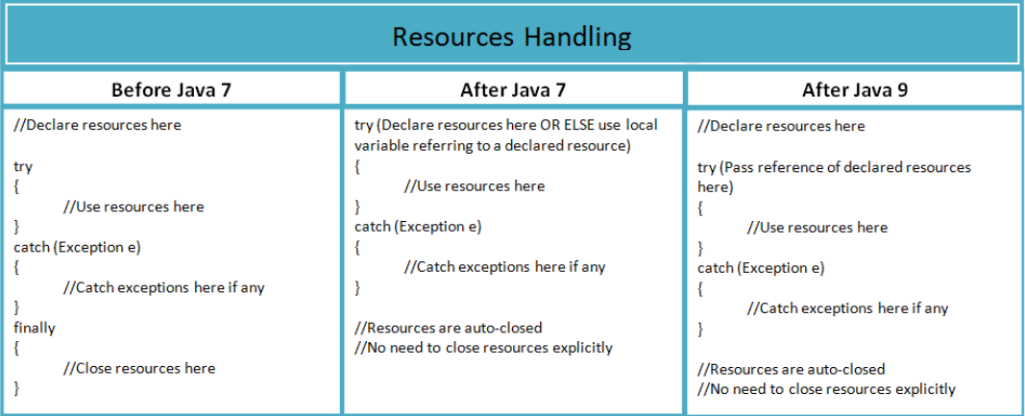
What will happen if an exception is thrown from the finally block?
If an exception is thrown from within the finally block, it will override any exception thrown in the preceding try block or catch block. However, the original exception will not be lost; it will still be accessible through the Throwable object thrown in the finally block.
Checked Exceptions (Compile time Exceptions):
IOException: Exception caused due to stream of InputOutput.
FileNotFoundExcepion: Subclass of IOException which occurs when file is not found in the specific path.
SQLException: Provides details on database access or others
NoSuchMethodException: Occurs when you're invoking a method through reflection, and the name of the method comes from a variable in your program
NoSuchFieldException: It is thrown when a class does not contain the field (or variable) specified
InterruptedException: It is thrown when a thread is waiting, sleeping, or doing some processing, and it is interrupted.
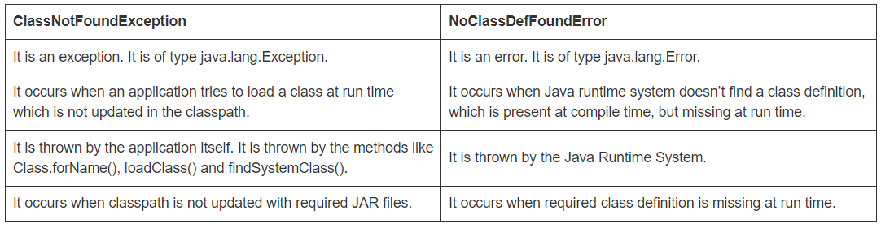
Unchecked Exceptions (Runtime Exceptions):
NullPointerException: When variable is accessed which is not pointing to any object or null.
ArithmeticException: Arithmetic Errors
ArrayOutOfIndexException: When accessing an array collection with wrong index.
ClassCastException: Try to cast improperly from one type to another
IllegalthreadStateException: Starting a thread twice or try to make a thread daemon after it start method.
ClassNotFoundException: This Exception is raised when we try to access a class whose definition is not found
NumberFormatException: This exception is raised when a method could not convert a string into a numeric format.
StringIndexOutOfBoundsException: It is thrown by String class methods to indicate that an index is either negative or greater than the size of the string.
NoSuchElementException: Thrown when one tries to access an iterable beyond its max limit.
ConcurrentModificationException: Occurs while try to modify the element during iteration.
InvalidClassException: In Serializable context if serial UID mismatch.
NonSerializableException: When the class does not implement serializable interface.
Spring Boot Exception Handling:
Default exception handling: Spring boot provides default exception handling with timestamp, status, http error, message and path.
Customized exception handling:
@ControllerAdvice [Global exception Handling]
Handle exception in whole application globally [Common for all controllers], Declared in class level.
@ExceptionHandler [Customized Exception Class]
Handle exception for specific handler class with custom implementation.
Always use Response Entity to return Body(message) and Response (Status, Error)

